Partitioned-Figure Composition

Definition
# Source: AI Source: Provided by: [Data Path: Persons Table -> ID Column: 1, Name_En Column: Motasem Essam] -> From: [ChatGPT] on [7/25/2026]
Partitioned-Figure Composition is a type of geometric figure composition in which a larger geometric figure is divided into two or more smaller regions by internal boundaries, such as line segments, diagonals, curves, or other dividing lines.
The resulting regions may be different shapes or multiple copies of the same shape. The boundaries between regions are usually internal and do not form part of the outer perimeter.
Simple definition: Partitioned-figure composition is a geometric figure divided into smaller parts that together form the whole figure.
Examples include:
- A rectangle divided into two triangles by a diagonal.
- A square divided into four smaller squares.
- A circle divided into several sectors.
- A polygon divided into triangles and other smaller polygons.

Main Classification
# Source: AI Source: Provided by: [Data Path: Persons Table -> ID Column: 1, Name_En Column: Motasem Essam] -> From: [ChatGPT] on [7/25/2026]
The following is a practical, descriptive classification, not a universally standardized mathematical taxonomy. The categories can overlap.

1. Line-Partitioned Composition
# Source: AI Source: Provided by: [Data Path: Persons Table -> ID Column: 1, Name_En Column: Motasem Essam] -> From: [ChatGPT] on [7/25/2026]
A figure is divided by one or more straight line segments.
Example: A rectangle divided into two triangles by a diagonal.
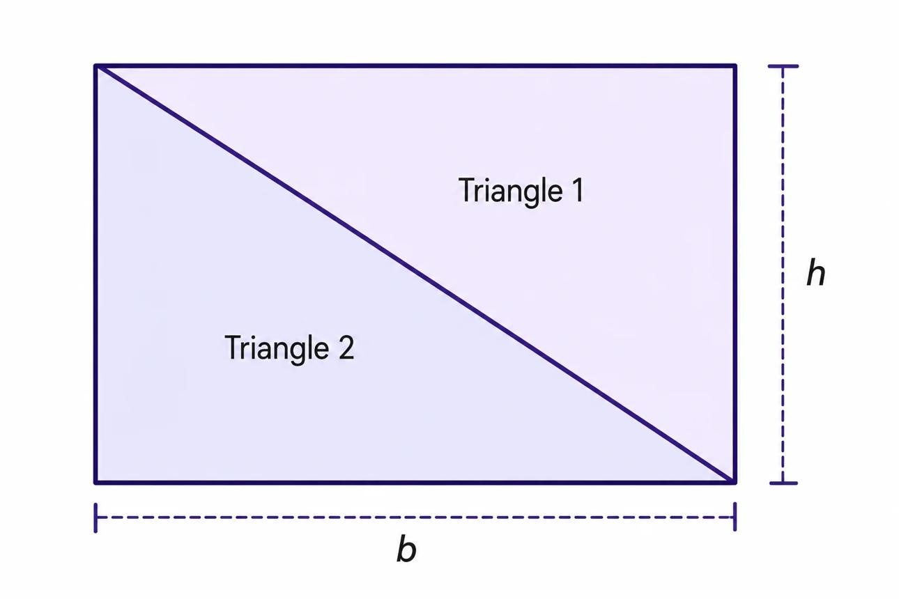
Detailed Explanation and Examples
Definition: A figure is divided into two or more regions by straight line segments drawn inside it.
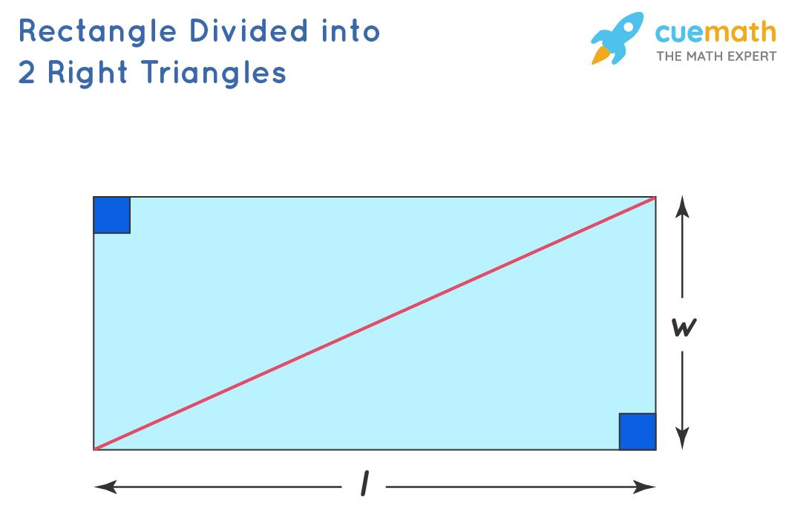
Example: A rectangle has length $12$units and width $8$units. A diagonal divides it into two triangles.
Total area:
$$A_{\text{rectangle}}=12×8=96$$
Each triangle has half the rectangle's area:
$$A_{\text{triangle}}=\frac{1}{2}\left(12\right)\left(8\right)=48$$
Therefore,
$$\boxed{A_{\text{rectangle}}=48+48=96}$$
Key principle: A diagonal divides a rectangle into two triangles of equal area.

2. Grid-Partitioned Composition
# Source: AI Source: Provided by: [Data Path: Persons Table -> ID Column: 1, Name_En Column: Motasem Essam] -> From: [ChatGPT] on [7/25/2026]
A figure is divided into a grid of smaller regions, often rectangles or squares.
Example: A square divided into a $3×3$grid of nine equal squares.
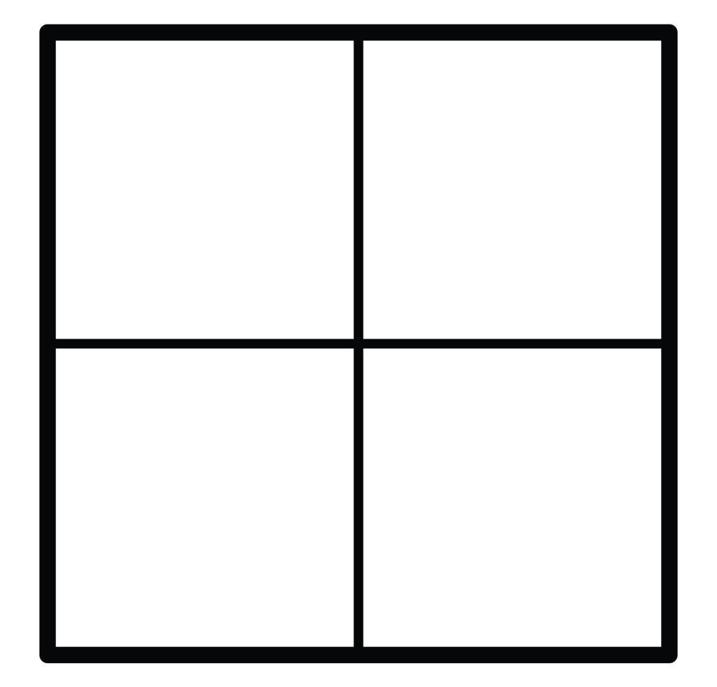
Detailed Explanation and Examples
Definition: A larger figure is divided into smaller regions arranged in rows and columns.
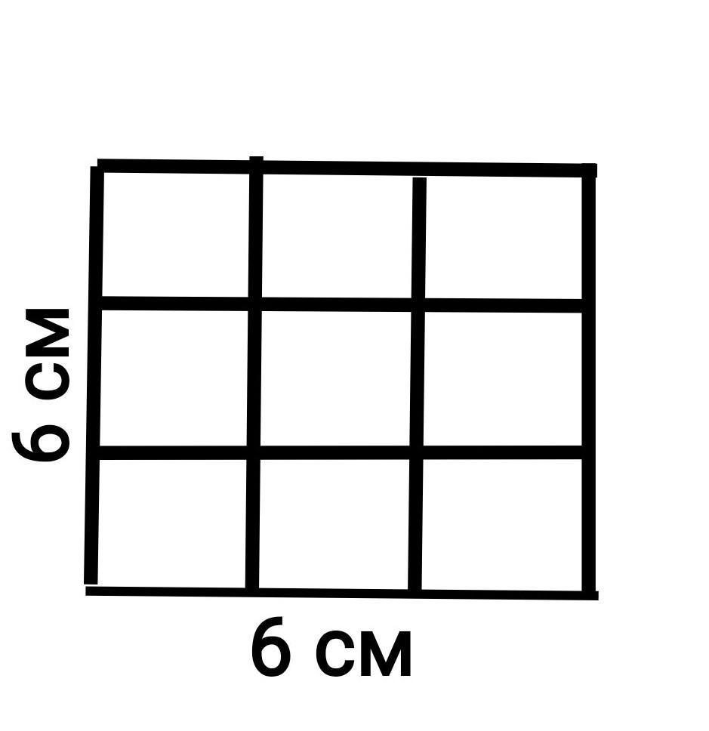
Example: A square has side length $6$units and is divided into a $3×3$grid.
Each small square has side length:
$$s=\frac{6}{3}=2$$
Area of each small square:
$$A_{\text{small}}=2^{2}=4$$
There are nine small squares, so:
$$\boxed{A_{\text{total}}=9\left(4\right)=36}$$
This equals the original square's area, $6^{2}=36$.

3. Polygon-Partitioned Composition
# Source: AI Source: Provided by: [Data Path: Persons Table -> ID Column: 1, Name_En Column: Motasem Essam] -> From: [ChatGPT] on [7/25/2026]
A polygon is divided into smaller polygons, commonly triangles.
Example: A pentagon divided into three triangles.
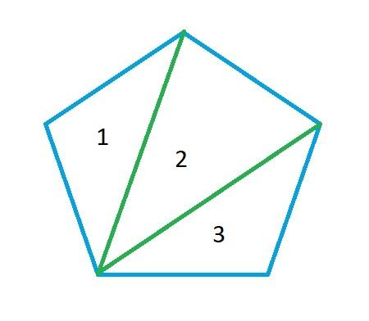
Detailed Explanation and Examples
Definition: A polygon is divided into smaller polygons, often triangles, using diagonals or other internal line segments.
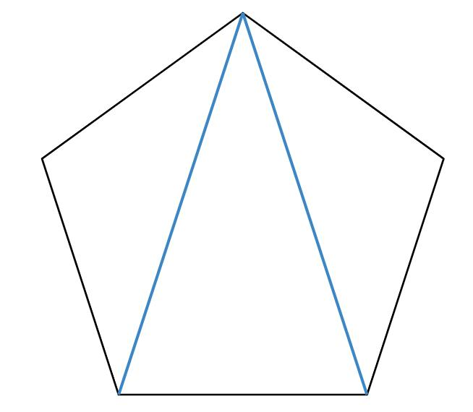
Example: A convex pentagon is divided into triangles by drawing diagonals from one vertex to its two nonadjacent vertices.
A convex polygon with $n$sides can be triangulated into:
$$\boxed{T=n-2}$$
For a pentagon, $n=5$, so:
$$T=5-2=3$$
If the three triangles have areas $10$, $12$, and $8$square units, the pentagon's total area is:
$$\boxed{A_{\text{pentagon}}=10+12+8=30}$$
The triangle areas must correspond to a valid partition of the polygon.

4. Circular-Partitioned Composition
# Source: AI Source: Provided by: [Data Path: Persons Table -> ID Column: 1, Name_En Column: Motasem Essam] -> From: [ChatGPT] on [7/25/2026]
A circular region is divided by radii, chords, or arcs.
Example: A circle divided into six equal sectors.
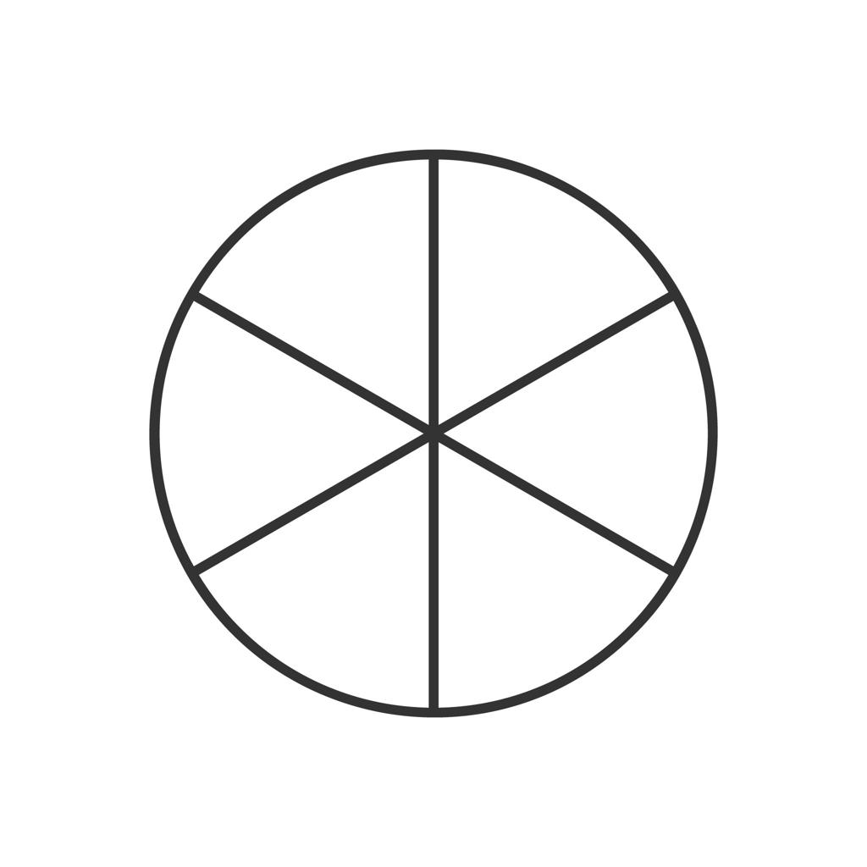
Detailed Explanation and Examples
Definition: A circular region is divided into smaller regions using radii, chords, or arcs.
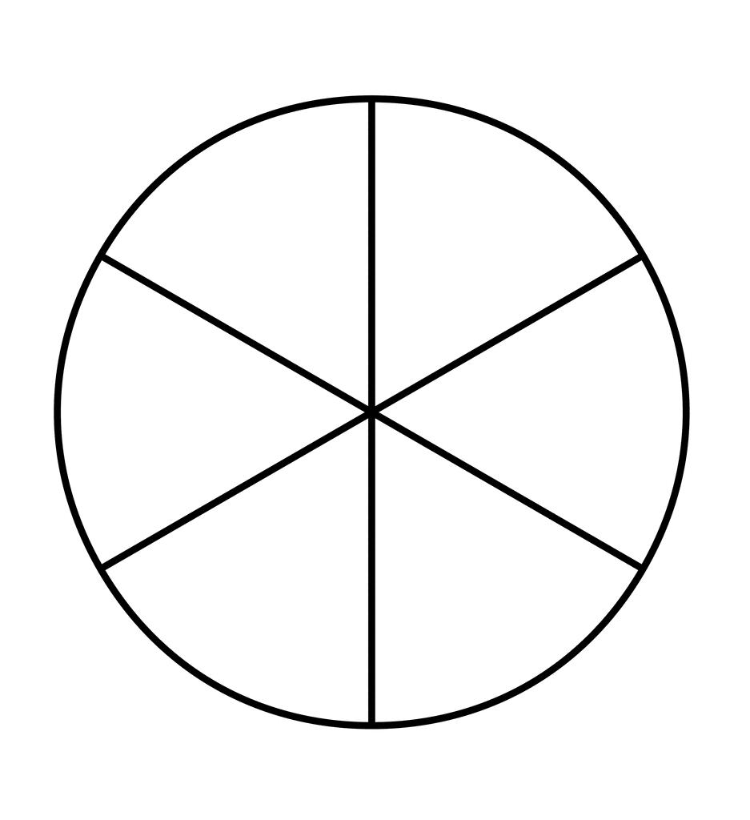
Example: A circle of radius $3$units is divided into six equal sectors.
The angle of each sector is:
$$θ=\frac{{360}^{∘}}{6}={60}^{∘}$$
The area of the entire circle is:
$$A=π{\left(3\right)}^{2}=9π$$
Each sector has area:
$$A_{\text{sector}}=\frac{9π}{6}$$
Therefore,
$$\boxed{A_{\text{sector}}=\frac{3π}{2}}$$
The six sectors together have area $9π$, equal to the area of the original circle.

5. Mixed-Region Partitioned Composition
# Source: AI Source: Provided by: [Data Path: Persons Table -> ID Column: 1, Name_En Column: Motasem Essam] -> From: [ChatGPT] on [7/25/2026]
A figure is divided into regions of different geometric types or sizes.
Example: A rectangle partitioned into a smaller rectangle and two triangles.
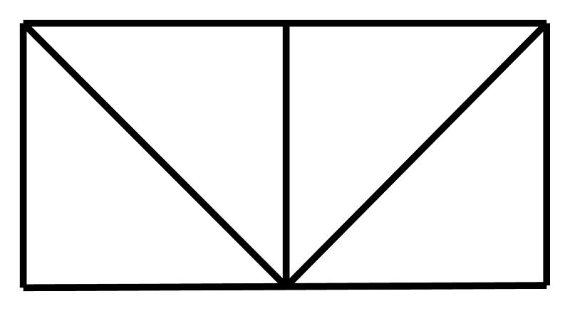
Detailed Explanation and Examples
Definition: A figure is divided into regions of different geometric types, such as rectangles and triangles.
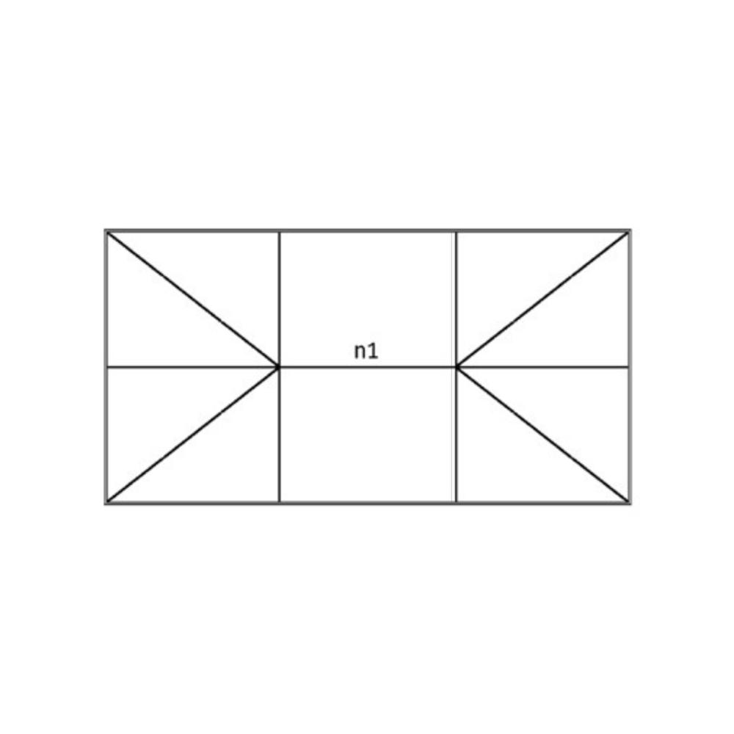
Example: A rectangle measuring $10×6$units is divided into a central rectangle of width $4$units and two triangles on either side. Each triangle has base $3$units and height $6$units.
Central rectangle:
$$A_{1}=4\left(6\right)=24$$
Each triangle:
$$A_{2}=\frac{1}{2}\left(3\right)\left(6\right)=9$$
Total area:
$$A_{\text{total}}=24+9+9$$
$$\boxed{A_{\text{total}}=42}$$
The component areas add up to the original rectangle's area, $10×6=60$, only if the partition dimensions cover the full width. Here, the widths $4+3+3=10$, so the correct total is:
$$\boxed{A_{\text{total}}=24+9+9=42}$$
This reveals an inconsistency: the stated triangle dimensions and rectangle partition do not describe two triangles that fill the remaining rectangular regions. If the two side regions are actually rectangles of width $3$and height $6$, each has area $18$, giving $24+18+18=60$. For a valid partition, the component shapes and dimensions must fit together exactly.

6. Unequal-Region Partitioned Composition
# Source: AI Source: Provided by: [Data Path: Persons Table -> ID Column: 1, Name_En Column: Motasem Essam] -> From: [ChatGPT] on [7/25/2026]
A figure is divided into regions that differ in area, shape, or both.
Example: A rectangle divided into one large region and two smaller regions.
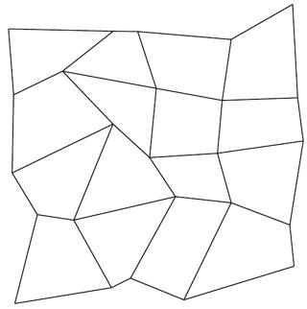
Detailed Explanation and Examples
Definition: A figure is divided into regions that differ in size, shape, or both.
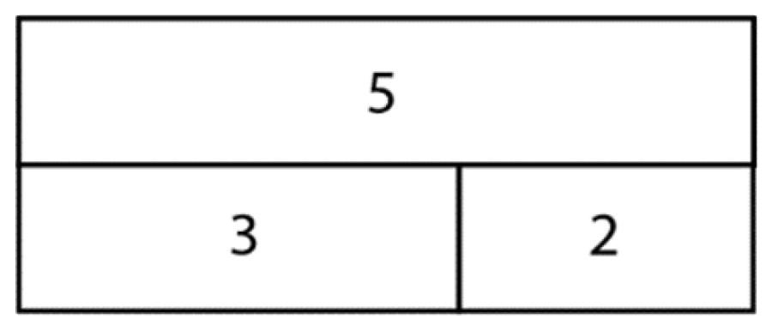
Example: A rectangle of height $4$units is divided into three smaller rectangles with widths $2$, $3$, and $5$units.
Their areas are:
$$A_{1}=2\left(4\right)=8$$
$$A_{2}=3\left(4\right)=12$$
$$A_{3}=5\left(4\right)=20$$
Thus,
$$\boxed{A_{\text{total}}=8+12+20=40}$$
The original rectangle has width $2+3+5=10$, so its area is $10×4=40$.

7. Multiple-Boundary Partitioned Composition
# Source: AI Source: Provided by: [Data Path: Persons Table -> ID Column: 1, Name_En Column: Motasem Essam] -> From: [ChatGPT] on [7/25/2026]
A figure is partitioned using several types or directions of internal boundaries.
Example: A square divided using horizontal, vertical, and diagonal segments.
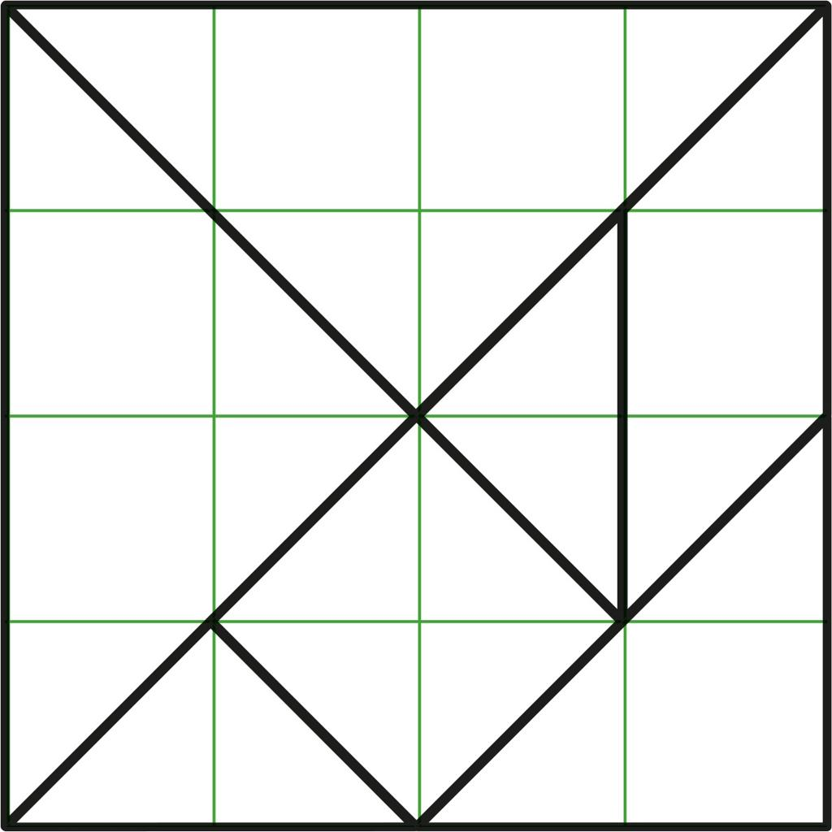
Detailed Explanation and Examples
Definition: A figure is divided using multiple internal boundaries, possibly including horizontal, vertical, diagonal, or curved lines.
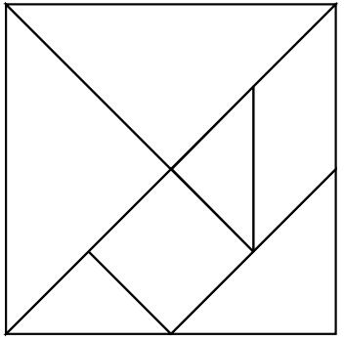
Example: A square is divided into four smaller squares, and one of those squares is divided diagonally into two triangles.
If the original square has side length $8$units, each of the four smaller squares has side length $4$units.
Area of each smaller square:
$$A_{\text{square}}=4^{2}=16$$
The diagonal divides one small square into two triangles of area $8$each.
The total area remains:
$$\boxed{A_{\text{total}}=3\left(16\right)+8+8=64}$$
This equals the original square's area, $8^{2}=64$.

Important Formulas and Principles
# Source: AI Source: Provided by: [Data Path: Persons Table -> ID Column: 1, Name_En Column: Motasem Essam] -> From: [ChatGPT] on [7/25/2026]
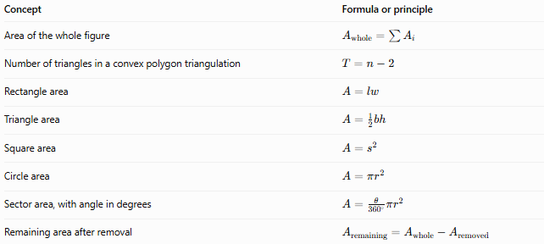
Concept | Formula or principle
Area of the whole figure | $$A_{\text{whole}}=\sum{A_{i}}$$
Number of triangles in a convex polygon triangulation | $$T=n-2$$
Rectangle area | $$A=lw$$
Triangle area | $$A=\frac{1}{2}bh$$
Square area | $$A=s^{2}$$
Circle area | $$A=πr^{2}$$
Sector area, with angle in degrees | $$A=\frac{θ}{{360}^{∘}}πr^{2}$$
Remaining area after removal | $$A_{\text{remaining}}=A_{\text{whole}}-A_{\text{removed}}$$
Important perimeter rule: Areas of non-overlapping partitioned regions add to the whole area, but their perimeters generally do not add to the outer perimeter. Internal dividing boundaries must be excluded when calculating the perimeter of the whole figure.

Partitioned-Figure Composition vs. Related Concepts
# Source: AI Source: Provided by: [Data Path: Persons Table -> ID Column: 1, Name_En Column: Motasem Essam] -> From: [ChatGPT] on [7/25/2026]
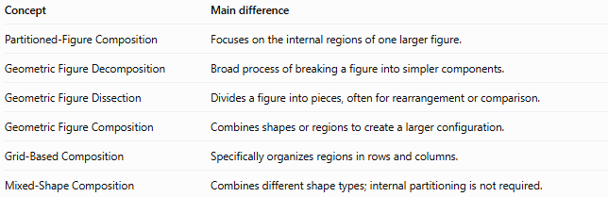
Concept | Main difference
Partitioned-Figure Composition | Focuses on the internal regions of one larger figure.
Geometric Figure Decomposition | Broad process of breaking a figure into simpler components.
Geometric Figure Dissection | Divides a figure into pieces, often for rearrangement or comparison.
Geometric Figure Composition | Combines shapes or regions to create a larger configuration.
Grid-Based Composition | Specifically organizes regions in rows and columns.
Mixed-Shape Composition | Combines different shape types; internal partitioning is not required.
Partitioning describes how a figure is subdivided. A partition may also be used for decomposition or dissection, depending on its purpose.

Classification Summary
# Source: AI Source: Provided by: [Data Path: Persons Table -> ID Column: 1, Name_En Column: Motasem Essam] -> From: [ChatGPT] on [7/25/2026]
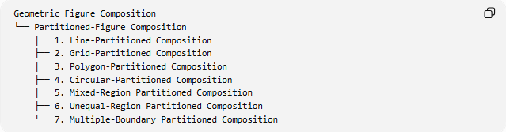
Geometric Figure Composition
└── Partitioned-Figure Composition
├── 1. Line-Partitioned Composition
├── 2. Grid-Partitioned Composition
├── 3. Polygon-Partitioned Composition
├── 4. Circular-Partitioned Composition
├── 5. Mixed-Region Partitioned Composition
├── 6. Unequal-Region Partitioned Composition
└── 7. Multiple-Boundary Partitioned Composition

Key Points
# Source: AI Source: Provided by: [Data Path: Persons Table -> ID Column: 1, Name_En Column: Motasem Essam] -> From: [ChatGPT] on [7/25/2026]
- A partition divides a larger figure into smaller regions.
- The regions can be equal or unequal in area and may have the same or different shapes.
- A valid partition covers the entire original figure without gaps or overlapping interiors.
- The total area equals the sum of the areas of all partitioned regions.
- Internal boundaries do not count toward the outer perimeter.
- The classification above is descriptive; the categories are not mutually exclusive.

Conclusion
# Source: AI Source: Provided by: [Data Path: Persons Table -> ID Column: 1, Name_En Column: Motasem Essam] -> From: [ChatGPT] on [7/25/2026]
Partitioned-Figure Composition describes a geometric figure organized into smaller regions by internal boundaries. It is useful for calculating areas, studying polygons, analyzing composite figures, and solving geometry problems. The central principle is that the parts must fit together to reproduce the original figure exactly.

